

Internship report

Cybersecurity Strategy Advisor
Internship Duration: 02/02/2026 ~ 31/07/2026
1 Rue Serpentines, 92400 Courbevoie Tutor: Alioune NDIAYE
Acknowledgements
I would like to express my deep gratitude to all the people who accompanied and supported me during my experience at Sopra Steria, a particularly enriching adventure both professionally and personally.
First of all, I would like to thank Sopra Steria for welcoming me to its teams as a Cybersecurity Strategy Advisor, allowing me to evolve in a demanding, stimulating and excellence-oriented environment. Joining a major player in consulting and digital transformation was a valuable opportunity to develop my understanding of the strategic issues related to cybersecurity.
I would like to express my sincere thanks to Alioune Ndiaye, my supervisor, for his support throughout this experience. His availability, his expertise and the quality of his advice have allowed me to progress significantly and to refine my strategic vision of cyber issues. His rigorous and benevolent supervision has been decisive in my professional development.
I would also like to thank all the employees with whom I have had the opportunity to exchange and work. Their professionalism, their team spirit and the richness of our exchanges greatly contributed to making this experience a structuring step in my career.
Thank you all for your trust, your accompaniment and your support.

Table of content
- Company Overview
- Introduction
- Work Schedule Description
- Description of Completed Tasks
4.1. Skills Development and Learning
4.2. Creation of a Cybersecurity Training Program
4.3. Maturity Assessment Audit
4.4. Roadmaps
- Results of Completed Tasks
5.1. Skills Development and Learning
5.1.1. SC-900 Certification Training
5.1.2. NIST Cybersecurity Framework (CSF)
5.1.2.1. Description
5.1.2.2. NIST CSF Template
5.1.3. CIS Controls
5.1.3.1. Description
5.1.3.2. CIS Controls Template
5.2. Creation of a Cybersecurity Training Program
5.2.1. Threats, Attacks and Vulnerabilities
5.2.2. Architecture and Frameworks
5.2.3. Security Implementation
5.2.4. Operations & Incident Response
5.2.5. Governance & Compliance
5.3. Maturity Assessment Audit

1. Company Overview
Sopra Steria is a leading European player in consulting, digital services, and software development. Present in multiple countries, the group supports large enterprises and public sector organizations in their digital transformation projects by combining industry expertise, technological innovation, and strategic vision.
With several decades of experience, Sopra Steria operates across key sectors such as:
- Financial services
- Defense and security
- Aerospace
- Energy and utilities
- Public sector and European institutions
- Telecommunications and transport
The company is recognized for its ability to manage complex transformation programs by integrating technological, organizational, and regulatory dimensions. Its approach is based on a deep understanding of business challenges and the use of advanced technologies such as cloud computing, data analytics, artificial intelligence, and cybersecurity.
A core area of expertise at Sopra Steria is cybersecurity, which plays a strategic role in supporting clients. In response to the growing number of threats and increasingly strict regulatory requirements, particularly regarding data protection and system resilience, the group develops comprehensive offerings covering:
- Cybersecurity governance and strategy
- Risk management and compliance
- Critical infrastructure protection
- Incident detection and response
- Securing cloud environments and industrial systems

The objective is to help organizations integrate cybersecurity at the core of their strategy, moving from a purely technical approach to a global risk management and value-creation perspective.

In addition, Sopra Steria places strong emphasis on Corporate Social Responsibility (CSR). The group implements concrete initiatives to reduce its carbon footprint, promote diversity and inclusion, and encourage ethical business practices. Policies such as remote work, energy optimization, and awareness of responsible digital practices contribute to this sustainable approach.
Thus, Sopra Steria positions itself as a key strategic partner for organizations seeking to combine performance, innovation, and security in an ever-evolving digital environment.

2. Introduction
I had the opportunity to join Sopra Steria as a Cybersecurity Strategy Consultant, within a dynamic environment where technological and strategic challenges are at the core of the missions. Working in this type of organization particularly appealed to me, as I have long been interested in the protection of digital systems and in the overall management of cyber risks within organizations.
My experience focused on cybersecurity maturity assessment audits, aimed at evaluating organizations’ level of preparedness against cyber risks and identifying key areas for improvement. Based on these audits, I contributed to defining target security profiles for systems and processes, as well as to the development of strategic roadmaps. These roadmaps outlined the actions to be implemented, their prioritization, and the resources required to reach an optimal level of cybersecurity.
These assignments allowed me to work on concrete and diverse challenges, including risk management, regulatory compliance, critical infrastructure protection, and the planning of corrective measures. The ultimate objective was to propose practical solutions tailored to clients’ specific needs, in order to both strengthen security and support their digital transformation.
The working environment at Sopra Steria, which is both demanding and stimulating, enabled me to develop strong skills in strategic auditing, cybersecurity planning, and operational consulting, while gaining a comprehensive understanding of risks and opportunities for organizations. Working within an expert and collaborative team was also a highly enriching professional and human experience.

3. Description of Completed Tasks
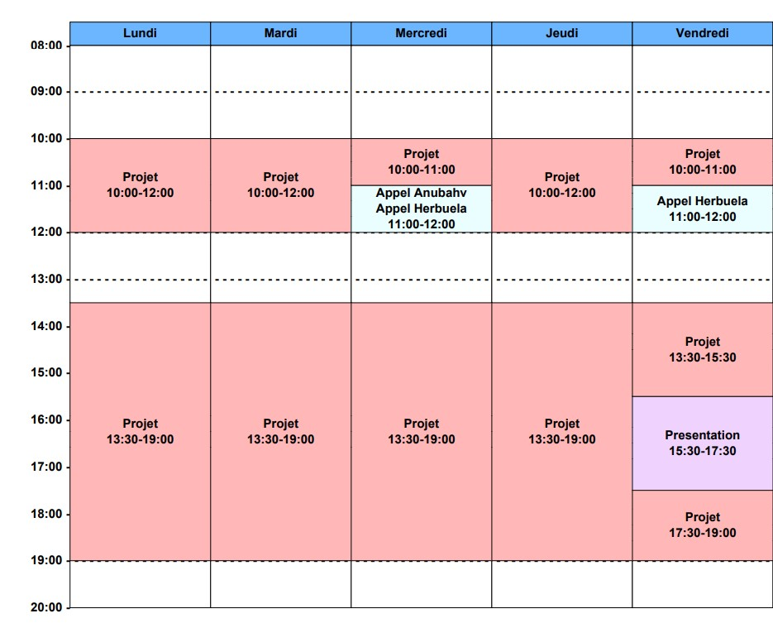

4. Description of Completed Tasks
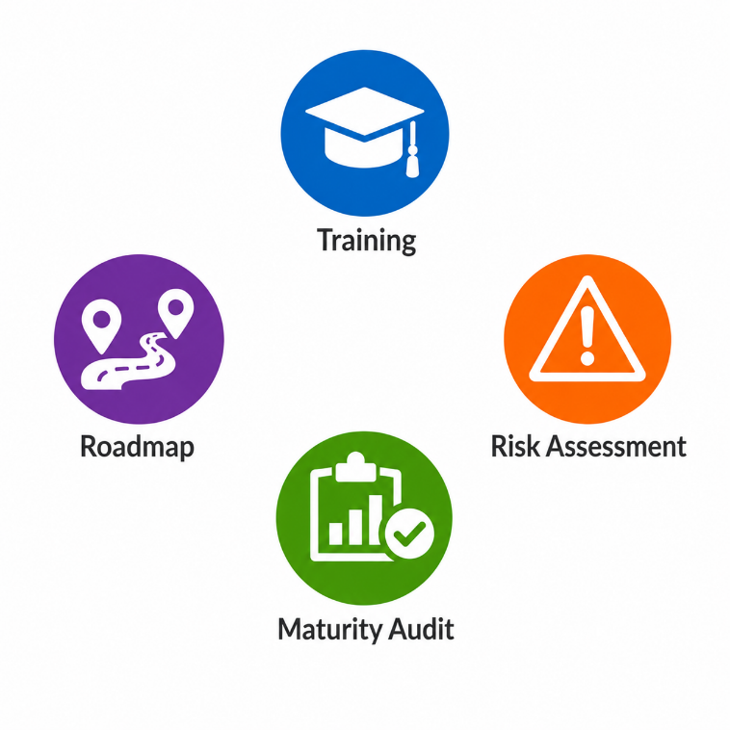

4.1. Skills Development and Learning

During my internship, I strengthened my cybersecurity skills through both formal training and self-learning.

In particular, I completed a preparatory training course for the SC-900 certification (Microsoft Security, Compliance, and Identity Fundamentals), which provided me with a global understanding of security, compliance, and identity management challenges in cloud environments.

In addition, I explored several cybersecurity frameworks and standards, including the NIST Cybersecurity Framework, which structures best practices around key functions such as governance, identification, protection, detection, response, and recovery.

These learning experiences enabled me to better understand the methodologies used in real-world assignments and helped me gain greater autonomy when working on cybersecurity topics.

4.2. Creation of a Cybersecurity Training Program
I contributed to the design of a cybersecurity awareness training program intended for employees of Elis.

The objective was to raise users’ awareness of best practices and of the risks associated with information system security.
The training covered several key topics, including password management, good practices for workstation usage, and appropriate behaviours in the event of a security incident. It also included awareness of different types of cyberattacks (phishing, ransomware, brute-force attacks, social engineering, etc.) as well as the methods used to prevent them.
I contributed to structuring the training content, defining key messages, and adapting the technical level to the target audience in order to ensure the training was both accessible and effective.

4.3. Maturity Assessment Audit
I contributed to the execution of cybersecurity maturity assessments aimed at evaluating the overall security level of an organization.
These assessments were based on cybersecurity frameworks and evaluation criteria in order to identify gaps between existing practices and expected best practices.
The objective was to determine the organization’s level of maturity and highlight key areas for improvement.

4.4. Roadmaps
Following the maturity assessments and analyses carried out, I contributed to the development of cybersecurity roadmaps.
The information collected during the audits provided a comprehensive view of the organization’s current security posture and enabled the identification of priority areas for improvement. Based on these findings, cybersecurity roadmaps were designed to define the actions to be implemented in the short, medium, and long term in order to strengthen the organization’s overall security level.
These roadmaps helped structure priorities and plan cybersecurity projects by detailing which actions should be implemented first, the human resources required, the estimated timelines, and the associated budget considerations. The prioritization of actions was mainly based on risk analysis, ensuring that the most critical vulnerabilities and highest-risk areas were addressed first. This approach enabled the organization to progressively improve its cybersecurity maturity through a realistic, strategic, and risk-oriented methodology.

5. Results of Completed Tasks

5.1. Skills Development and Learning
During my internship, I enhanced my cybersecurity skills through training programs and self-learning initiatives.

5.1.1. SC-900 Certification Training
The SC-900 training course provides an introduction to the fundamental concepts of security, compliance, and identity management within cloud environments, particularly those related to Microsoft technologies. Its main objective is to help participants understand the key cybersecurity and compliance concepts involved in modern information systems. During this training, I studied identity and authentication security, including user identity management, multi-factor authentication (MFA), and access management. I also explored governance and compliance topics, such as the definition of security policies, sensitive data management, and information protection within cloud environments. In addition, the training introduced me to the tools and solutions offered by Microsoft to effectively secure both cloud and hybrid infrastructures. It provided me with a broader understanding of cybersecurity and compliance challenges, which is essential when advising clients on security strategies and best practices. This training also strengthened my understanding of cloud-related risks, as cloud technologies are increasingly adopted by organizations. Furthermore, it enabled me to better identify the security solutions and recommendations that can be implemented to protect information systems in real-world consulting assignments.
5.1.2. NIST CSF (Cybersecurity Framework)
5.1.2.1. Description
During my internship, I discovered and learned to use the NIST Cybersecurity Framework (CSF), a guideline used to structure cybersecurity risk management. I became familiar with its different core functions (Figure 1) and understood how they can be applied in practice to analyze information systems, assess risks, and propose appropriate security measures.

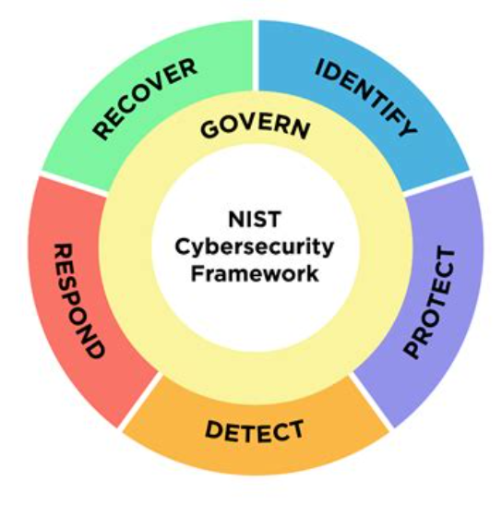
Figure 1 : NIST Cybersecurity Framework

Gouvernance: The Govern function provides outcomes that help an organization determine what it can do to achieve and prioritize the objectives of the other five functions, in alignment with its mission and stakeholders’ expectations.
Identification: This function aims to understand and map assets, systems, data, and associated risks. It enables the prioritization of security actions based on the criticality of the elements to be protected.
Protection: This function includes all measures implemented to secure systems and information, such as access management, multi-factor authentication, encryption, and user awareness training.
Detection: It focuses on the rapid identification of cybersecurity incidents through system monitoring and alerting tools, enabling timely response before damage spreads.
Response: This function defines the processes used to contain, manage, and resolve security incidents, including team coordination, communication, and remediation activities.
Recovery: It aims to restore services and data after an incident in order to ensure business continuity and improve the resilience of the information system.

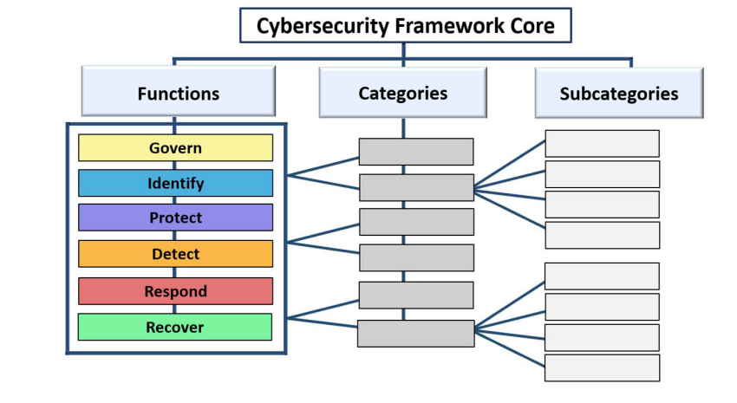
Figure 2: Cybersecurity Framework Core
Each function of the NIST Cybersecurity Framework (CSF) is organized into categories, which represent specific areas of cybersecurity. Each category is then further detailed into subcategories corresponding to concrete actions or controls to be implemented.
Overall, the framework includes 106 subcategories. This structure enables a transition from a high-level view of security objectives to practical and measurable actions. It facilitates risk analysis, action planning, and the assessment of an organization’s cybersecurity maturity.
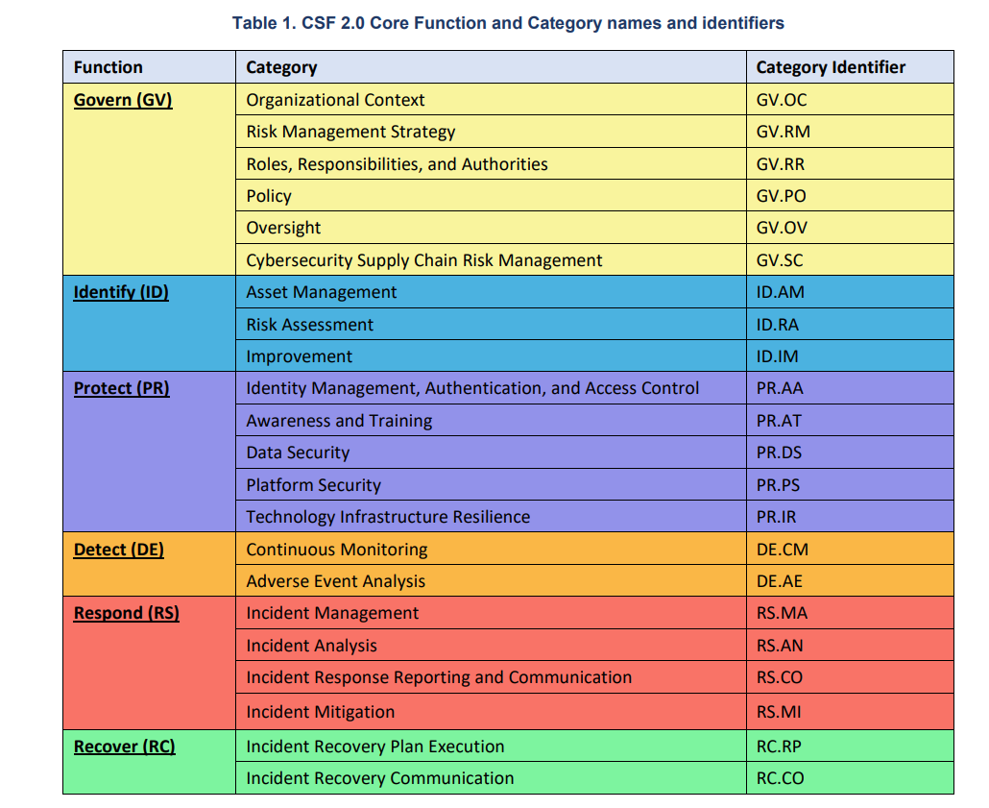

Example of a category and its subcategories:
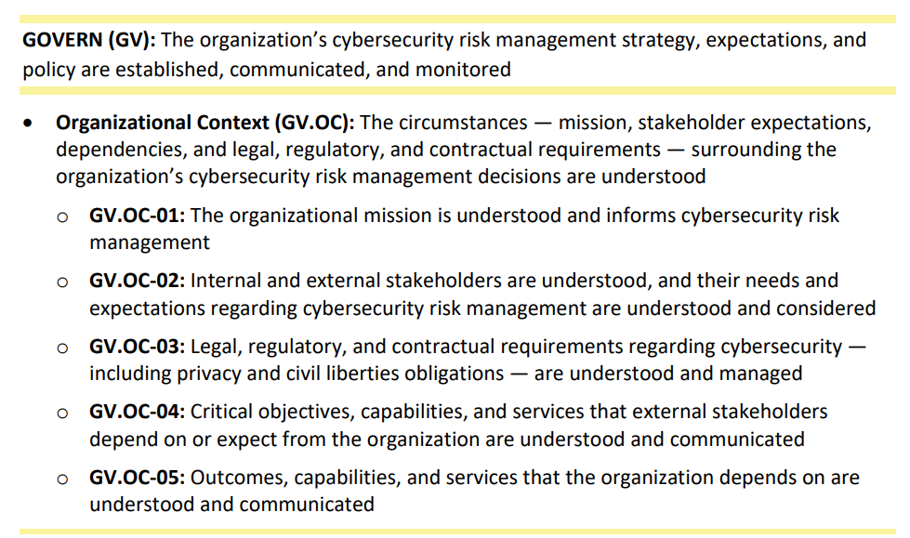
Figure 3: Example of a NIST CSF category and its subcategories

This framework helps structure all cybersecurity activities within an organization. It serves as a guide for defining actions, identifying gaps in existing practices, and prioritizing security measures. In addition, it facilitates the development of cybersecurity roadmaps and action plans by aligning corrective measures with the organization’s strategic objectives and governance. By understanding and applying this framework, it becomes possible to effectively advise organizations on risk management and the implementation of appropriate security solutions.

5.1.2.2. NIST CSF Template
I developed an Excel-based template to support cybersecurity maturity assessments conducted with clients. The objective of this tool is to structure and standardize the audit process based on the NIST Cybersecurity Framework (CSF). It is designed for use during IT cybersecurity maturity assessments and serves as a foundation for both evaluation and roadmap definition. The template is structured into three main sections.

The first section is a usage guide presented to the client at the beginning of the assessment. It explains the purpose of the framework, its role in the audit process, how the evaluation will be conducted, and how scoring is performed. It also describes the overall methodology and the expected outcomes of the workshop.

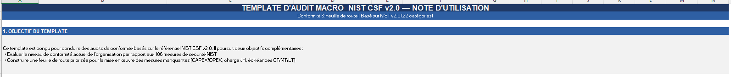
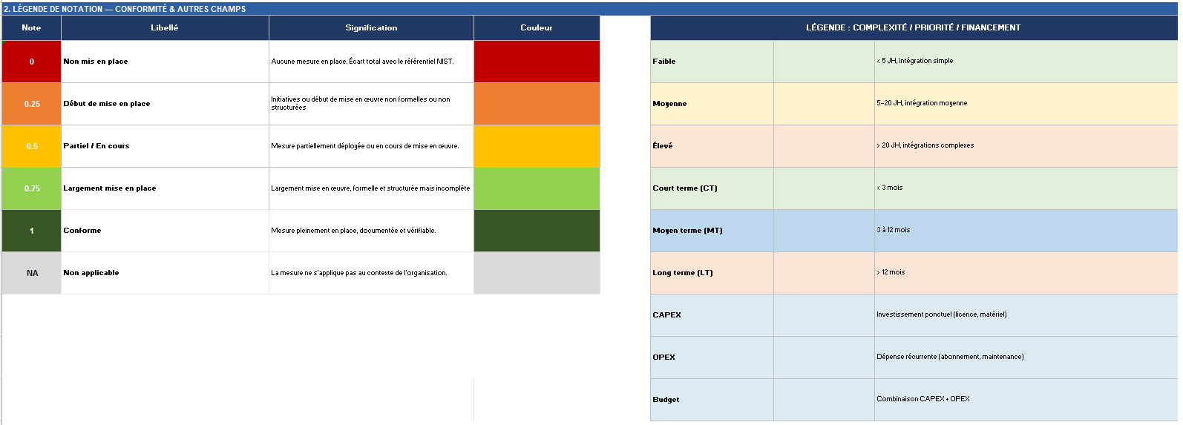
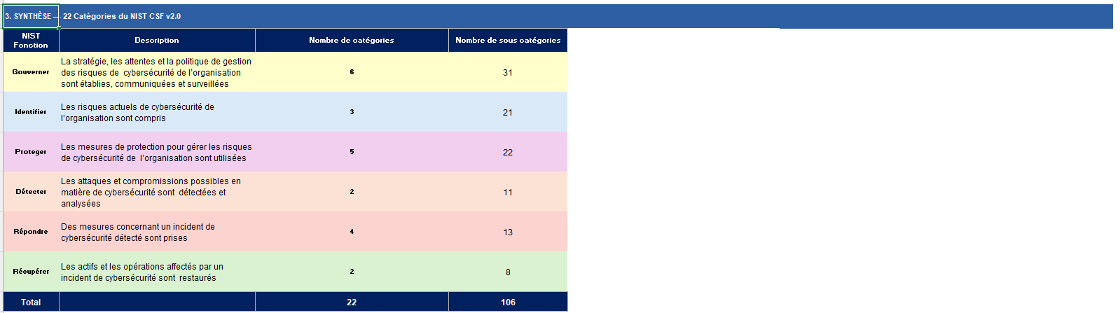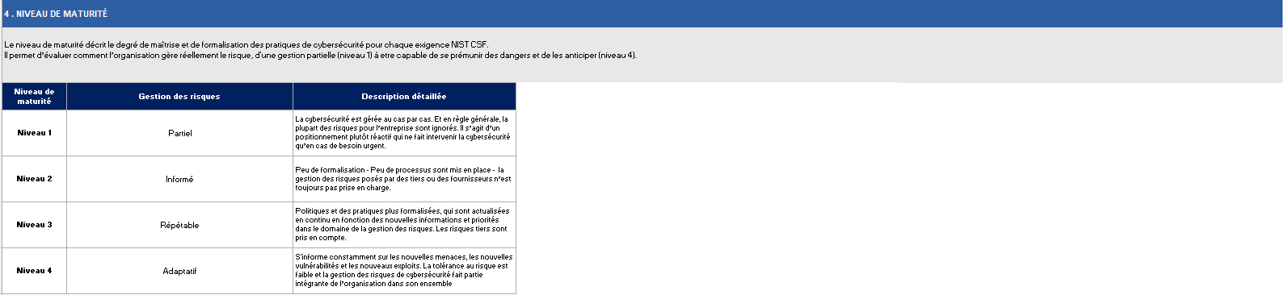
Figure 4: Cybersecurity Maturity Assessment Template – Introduction and Usage Guide
The second section is the main audit worksheet used during the assessment. It is organized by cybersecurity categories (rather than subcategories, in order to simplify the analysis and ensure a more operational approach). For each category, it includes a description of the domain, implementation examples, key questions to ask the client, and expected evidence.
This section also includes a scoring system based on the client’s current level of implementation. Existing controls are highlighted in green, while the gap between the current state and the target security profile is highlighted in orange. This gap analysis helps identify priority improvement areas.
In addition, the template integrates several evaluation criteria, including the criticality level of each requirement, implementation complexity, estimated number of resources required, budget considerations, and additional comments. These elements are used to support the definition of the cybersecurity roadmap and the planning of future security initiatives.
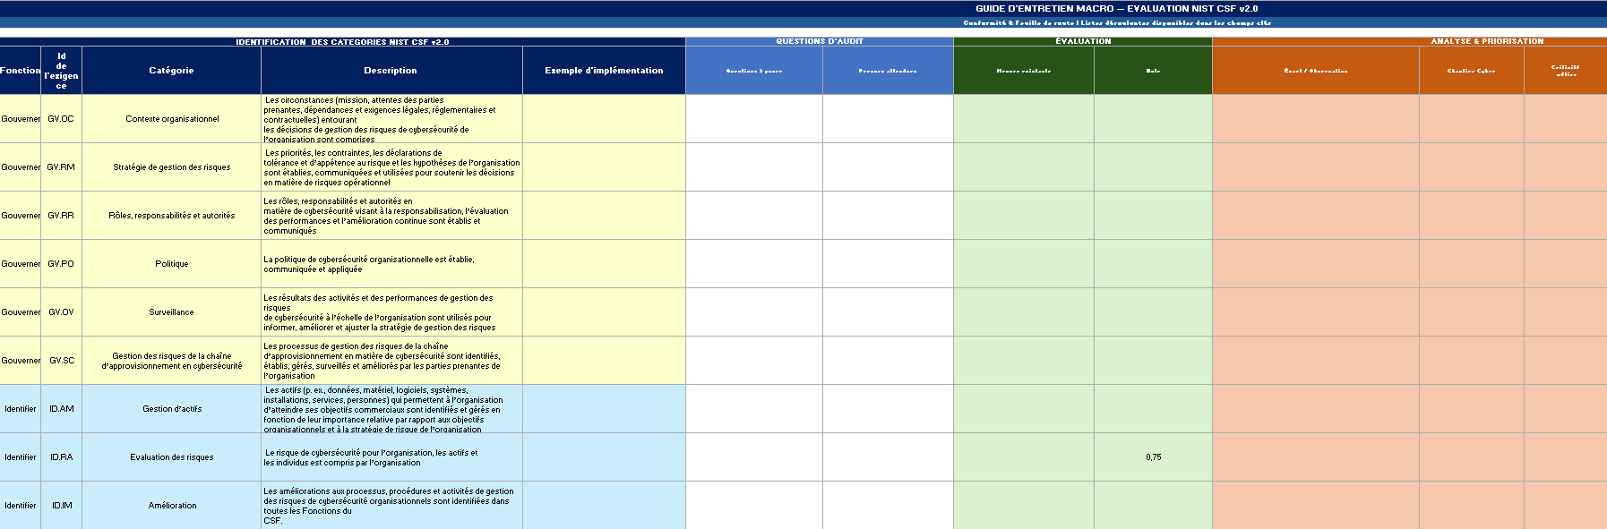
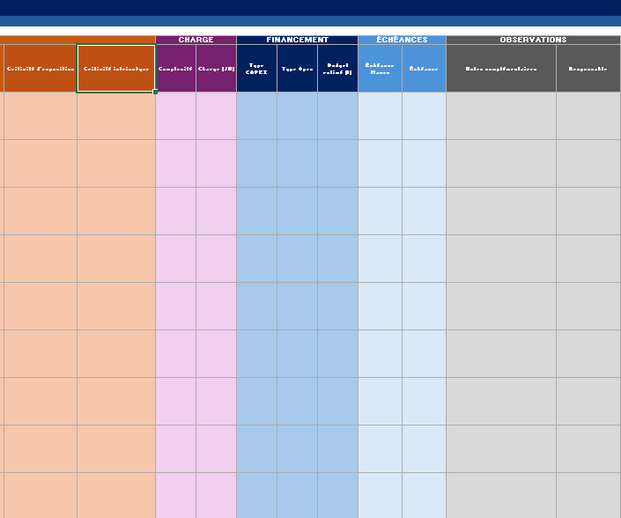
Figure 5: Cybersecurity Maturity Assessment Worksheet – NIST CSF Categories and Evaluation Matrix
The third section is a dashboard that provides a consolidated overview of the assessment results. Based on the scores defined in the second section, it highlights priority actions and their associated criticality levels according to different target scenarios. These scenarios may vary depending on project timelines and client constraints (for example, defining target compliance levels for July or August). The dashboard also generates visual graphs that illustrate the organization’s cybersecurity maturity level, which will be further explained later in the report.

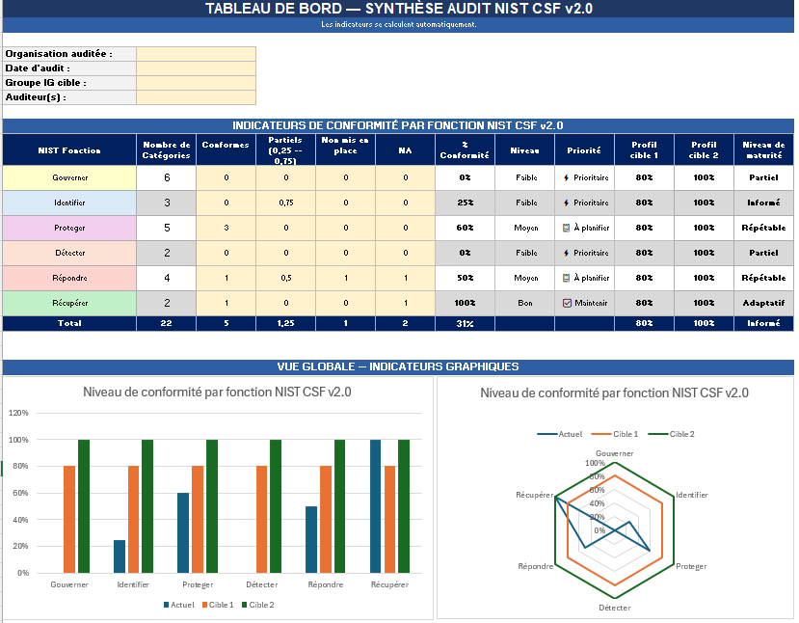
Figure 6: Cybersecurity Maturity Assessment Dashboard – Results Overview and Maturity Scoring
Finally, I designed this template myself, and it was later adapted based on client feedback and project-specific requirements. While a standard version was initially validated, it was adjusted in certain cases to better meet specific expectations and constraints.

5.1.3. CIS Controls (Center for Internet Security Controls)
5.1.3.1. Description

The CIS Controls (Center for Internet Security Controls) are a set of 18 best cybersecurity practices designed to help organizations reduce risks and improve their overall security posture. They provide a structured and prioritized approach to implementing security measures across key areas such as asset management, access control, data protection, monitoring, and incident response.

The framework is organized into three Implementation Groups (IG1, IG2, and IG3), which allow organizations to adapt security requirements based on their level of maturity, available resources, and risk exposure. IG1 covers essential security practices that should be implemented by all organizations. IG2 includes more advanced controls for organizations with greater resources and a higher level of maturity. IG3 targets highly mature environments with significant risk exposure, requiring more comprehensive and continuously managed security measures.

CIS Controls also define several asset classes to ensure full coverage of an organization’s environment. The Devices category includes all enterprise assets used for processing and storing data, such as end-user devices, servers, network equipment, IoT devices, and removable media. These assets can operate in physical, virtual, or cloud environments.

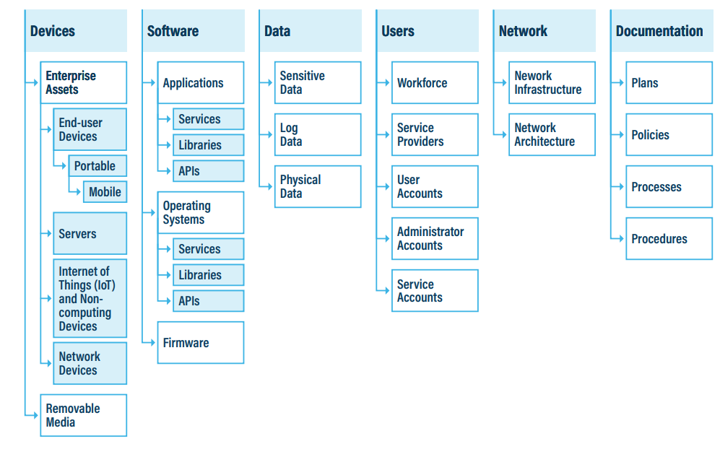
Figure 7 : CIS Control Classes Assets

Below is an example of a CIS Control, illustrating how the framework translates cybersecurity principles into concrete and actionable security measures. This example helps demonstrate the practical nature of CIS Controls and how they can be applied within an organization to reduce specific cyber risks.
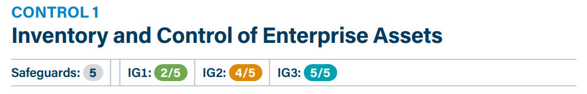
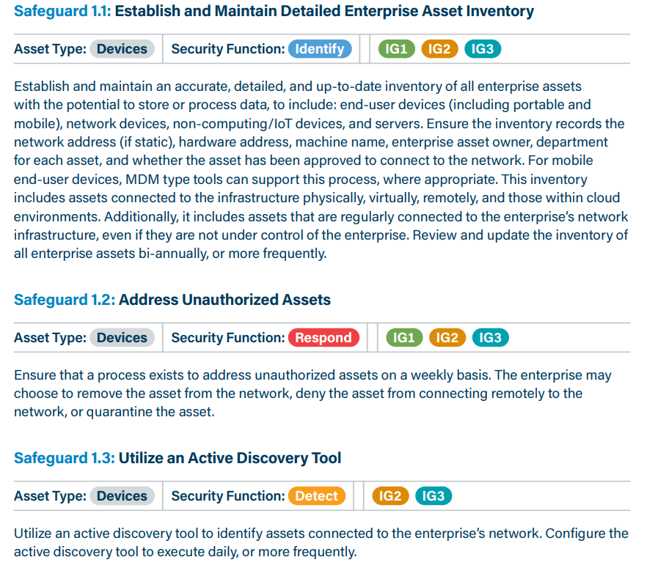
Figure 8: CIS Control Exemple

Although both CIS Controls and the NIST Cybersecurity Framework (CSF) aim to improve an organization’s cybersecurity posture, they differ in their approach and level of abstraction.
The NIST CSF is a high-level, risk-based framework used to structure cybersecurity strategy and governance. It helps organizations define objectives, assess maturity, and build strategic roadmaps. It is often used in cybersecurity consulting to evaluate the overall security posture and identify gaps across broad functions such as Identify, Protect, Detect, Respond, and Recover.
In contrast, CIS Controls are more operational and technical. They provide specific and actionable safeguards that can be directly implemented to reduce cyber risks. While NIST defines “what should be achieved,” CIS focuses more on “how to implement it” through concrete security measures.
For example, under the NIST CSF, an organization may identify the need to “improve access control management” as a strategic objective within the Protect function. The equivalent CIS Control would provide specific actions such as enforcing multi-factor authentication, implementing least privilege access, and regularly reviewing user permissions.
In this way, NIST CSF is mainly used to structure strategy and maturity assessment, while CIS Controls are used to guide the practical implementation of security measures.

5.1.3.2. CIS Controls Template
In the same way as for the NIST Cybersecurity Framework, I developed a dedicated template for the CIS Controls. This template follows a similar structure and is designed to support cybersecurity maturity assessments by translating the CIS framework into practical evaluation criteria. It enables the assessment of implemented safeguards, the identification of gaps, and the prioritization of security improvements based on the organization’s current maturity level.

5.2. Creation of a Cybersecurity Training Program
In order to strengthen the security culture within the Elis group, I contributed to the development of a comprehensive training material of 160 slides that provides a 360-degree view of cybersecurity intended for employees. The objective was to simplify complex technical concepts and make them accessible to all users.
This training was structured around five educational modules:
- Threats, Attacks, and Vulnerabilities
- Architecture and Frameworks
- Security Implementation
- Operations & Incident Response
- Governance & Compliance

5.2.1 Threats, Attacks, and Vulnerabilities
This first training module covers the fundamentals of cybersecurity by addressing four main topics: the core principles of information security through the DICT model, different types of malware, the concept of vulnerabilities and their assessment, and the main categories of attacks to which Elis Group systems may be exposed.
DICT (Availability, Integrity, Confidentiality, Traceability):
Information security is based on four essential properties, known as DICT:
- Availability: systems and data must be accessible to authorized users whenever needed.
- Integrity: information must not be altered or modified without authorization.
- Confidentiality: sensitive data must only be accessible to authorized individuals.
- Traceability: all actions performed on a system must be logged and auditable.

Malware:
Malware (malicious software) refers to programs designed to harm or disrupt information systems. There are several types, including viruses, worms, botnets, logic bombs, ransomware, and Trojans. Each type represents a specific threat and can impact the availability, integrity, or confidentiality of organizational data.
Vulnerabilities and CVSS scoring:
A vulnerability is a weakness in a system, application, or process that can be exploited by an attacker. Its severity is assessed using the Common Vulnerability Scoring System (CVSS), which assigns a score from 0 to 10. A score above 7 is generally considered critical and requires immediate remediation.
Risk in cybersecurity:
In cybersecurity, risk is defined as the combination of a threat, a vulnerability, and potential impact. The higher the likelihood of a threat exploiting a vulnerability and the greater the potential consequences, the more critical the risk becomes. A high risk does not necessarily mean an attack is imminent, but that the potential impact on the organization could be significant in financial, operational, or reputational terms.
Cyberattacks:
Information systems are exposed to a wide variety of attacks, including replay attacks, zero-day exploits, brute-force attacks, SQL injection, Cross-Site Scripting (XSS), and Distributed Denial of Service (DDoS) attacks. These threats target both network infrastructure and business applications and can have a direct impact on operational continuity.
Defense in depth:
Given the diversity of these threats, a perimeter-based security approach is no longer sufficient. The defense-in-depth principle consists of implementing multiple independent layers of security. If one layer is breached, the others continue to provide protection and help contain the attack.

5.2.2 Architecture and Frameworks
This module presents the main frameworks and principles that structure information system security. It covers the different cloud service models (IaaS, PaaS, SaaS) and their security implications in terms of shared responsibility between providers and clients.
It also introduces key regulatory and security frameworks such as those defined by ANSSI and CNIL, which provide guidelines and best practices for ensuring compliance and data protection.
In addition, fundamental architectural principles are addressed, including Zero Trust, which is based on the principle of “never trust, always verify,” and Security by Design, which consists of integrating security from the early stages of system design.
Finally, this module covers Identity and Access Management (IAM), including the concepts of identification, authentication, and authorization, as well as best practices related to password policies and access control mechanisms.

5.2.3 Security Implementation
This module focuses on practical tools and methods used to ensure the operational security of information systems.
From a network perspective, it introduces the concepts of LAN, MAN, and WAN in order to understand different infrastructure scales. It also covers key security tools such as VPNs for securing remote communications, Web Application Firewalls (WAF) for protecting web applications, and Wireshark for network traffic analysis. In addition, microsegmentation is presented as a technique used to limit lateral movement within a network in the event of a security breach.
In terms of data protection, the module explains password hashing and salting mechanisms, which ensure that credentials are securely stored and significantly more resistant to compromise.
Regarding system security, the hardening principle is introduced as a process aimed at reducing the attack surface by removing unnecessary services, configurations, or functionalities. This approach is complemented by the use of Endpoint Detection and Response (EDR) solutions to detect and respond to threats on endpoints.
Finally, the module addresses two major modern approaches in cybersecurity: DevSecOps, which integrates security throughout the software development lifecycle, and the OWASP Top 10, which identifies the ten most critical web application vulnerabilities and serves as a key reference for both developers and security teams.

5.2.4. Operations & Incident Response
This module focuses on monitoring, incident management, and business continuity. It introduces the Security Operations Center (SOC) as the central unit responsible for continuously monitoring the information system. The SOC relies on a Security Information and Event Management (SIEM) system to collect, correlate, and analyze security events in real time in order to detect any suspicious activity.
The module also covers the two main pillars of organizational resilience: the Disaster Recovery Plan (DRP), which defines the procedures for restoring systems after a major incident, and the Business Continuity Plan (BCP), which aims to ensure the continuity of critical business functions even during a crisis.
Finally, an introduction to penetration testing (pentesting) provides insight into how organizations proactively assess their security posture. Three main approaches are distinguished: white-box testing, where the tester has full knowledge of the target system; black-box testing, where the tester operates without any prior information, simulating an external attacker; and grey-box testing, which represents a hybrid approach combining elements of both. Grey-box testing is the most commonly used approach in enterprise environments.

5.2.5. Governance & Compliance
This module addresses the governance and compliance aspects of cybersecurity. It covers the main security policies defined within an organization and their role in structuring and enforcing security rules across all systems and users.
It also introduces the use of international standards and frameworks, such as ISO/IEC 27001, which provide structured requirements for implementing and maintaining an Information Security Management System (ISMS). These standards are often used as a reference for defining internal security policies and ensuring regulatory compliance.
Finally, the module includes the concept of security audits, which are used to evaluate the level of compliance of an organization against these frameworks and policies. These audits help identify gaps, assess risks, and ensure continuous improvement of the security posture.

5.3. Maturity Assessment Audit
5.3.1. Objective and Methodology
The cybersecurity maturity assessment audit is a structured approach used to evaluate the current security posture of an organization. Its purpose is to identify existing security measures, detect gaps compared to best practices, and establish a measurable level of cybersecurity maturity.
The assessment is based on the NIST Cybersecurity Framework (CSF), where each of the 106 requirements is evaluated and scored from 0 to 1 depending on the level of implementation. This scoring enables a detailed and quantitative view of the organization’s cybersecurity maturity.
The audit is conducted through workshops lasting approximately two hours, during which discussions focus on existing controls, operational practices, and security measures already in place.

